Abhinav Suri

Programming Projects 1.1 and 1.2

August 26, 2014

AP CS- Period 5

1.1:

Output:

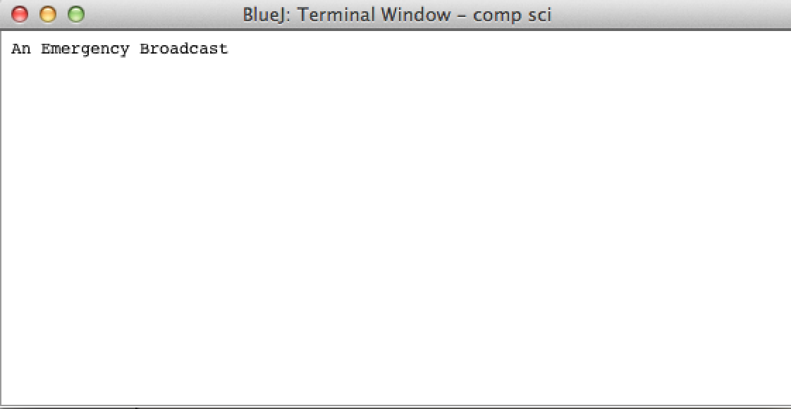

1.2

a. Prediction: no change to output.

Results: no change to output since class names allow for non-capitalizations. Class name change to “test”

b. Prediction: change in output to “An emergency Broadcast”

Results: change in output to “An emergency Broadcast”. Strings allow for different characters and capitalizations. No error.

c. Prediction: compile time error since the syntax of the program would not be correct.

Results: Failure to compile due to syntax error



d. Prediction: compile time error since the syntax of the program would not be correct.

Results: Failure to compile due to syntax error

e. Prediction: no change to syntax, just change to method name

Results: no error. Method name change

f. Prediction: Compile error. Method “bogus” does not exist.

Results: error “Cannot find symbol – method bogus(java.lang.String)”

g. Prediction: compile time error since the syntax of the program would not be correct.

Results: “ ‘;’ expected”

h. Prediction: compile time error since the syntax of the program would not be correct.

Results: error “Reached end of file while parsing” due to syntax error.